20160706
# To easyer connect to console to several dell servers you can use previously prepaired java applet for defined servers.
# Just download one via opening dell server console from google chrome and edit this file, then copy it for all of servers.
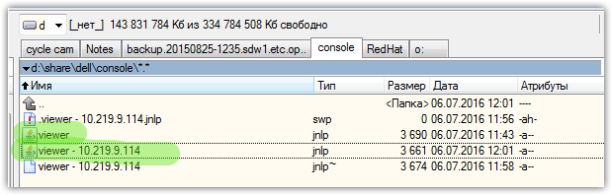
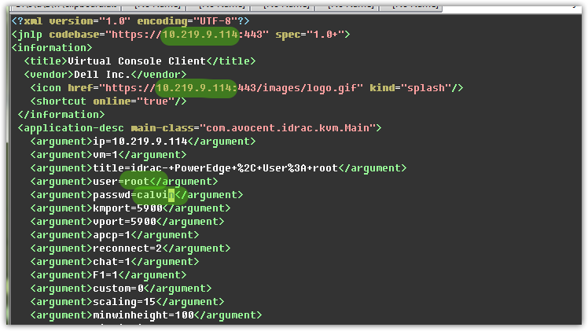
:%s/10.219.9.113/10.219.9.114/gc

